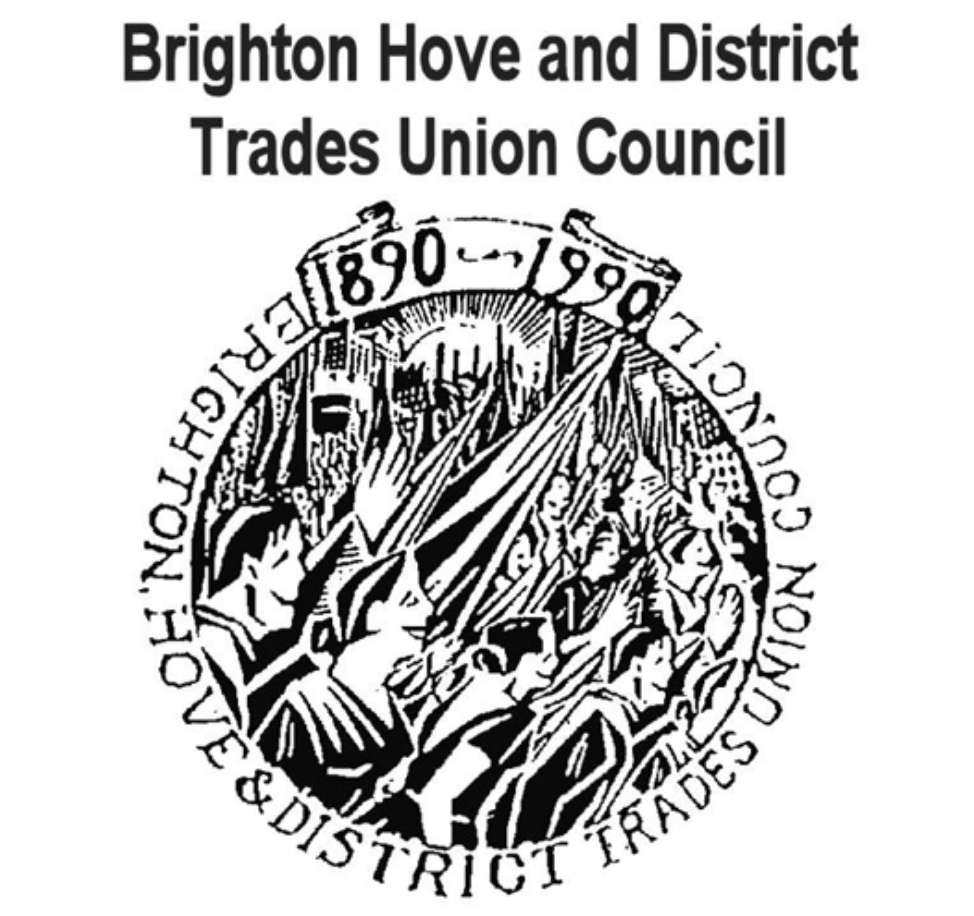
Sussex Defend the
NHS
Workers Campaigners Communities Together

The Tories are wrecking our NHS. Don’t let them get away with it!
The Government is trying to bully Junior Doctors by imposing a new contract which is UNSAFE and UNFAIR.

Other NHS workers and their patients are already paying the price for new contracts – reduced staffing, worse hours, service cuts – imposed through outsourcing and privatisation. We’ve got to stop this attack on working conditions and quality of care in the NHS.

Support the Junior Doctors march in Brighton on Tues 26 April (see overleaf)

March to Royal Sussex County Hospital Tues 26 April

Gather in front of Brighton Centre (venue for Unison Health Conference) 8am

March to RSCH 9am
Junior Doctors are withdrawing all labour for 18 hours from 8am -5pm on 26 & 27 April. They’ve been forced to take this unprecedented action. If they lose, all NHS workers face losing their national terms and conditions. Forced academisation of schools is intended to have the same effect on teachers.

Junior doctors are fighting for our NHS. Now all of us – NHS workers, patients, teachers, council workers, transport, construction workers– need to show our SOLIDARITY with them in their fightback.

Bring union banners and all supporters.
Called by Brighton Hove and District Trades Union Council. brightontradescouncil@gmail.com, local BMA and supported by Sussex Defend the NHS http://defendthenhssussex.weebly.com

